Name____________________________________

ABE 30800 – Spring 2018

Quiz 3 – March 6, 2018

1. What is the primary difference between natural convection and forced convection? Which mode usually has the higher heat transfer coefficient and why?

**[20 marks]**

Natural convection is when the fluid involved in the heat transfer is only moved by changes in viscosity with respect to the temperature. Air close to a heater is an example of natural convention.

Forced convection is when the fluid involved in the heat transfer is moved by a fun, a pump. An example could be the heater in a car with the fan on.  
2. (a) For a fluid flow circulating inside a tube and heated with a constant heat flow through the tube wall, **indicate graphically** how does the mean temperature (averaged over the radius) varies with the distance from the tube entrance in a fully developed region.

(b) For a fluid flow circulating inside a tube with a constant temperature in the tube, **indicate graphically** how does the mean temperature (averaged over the radius) varies with the distance from the tube entrance in a fully developed region.

**[40 marks]**

**Constant flow Constant Temperature**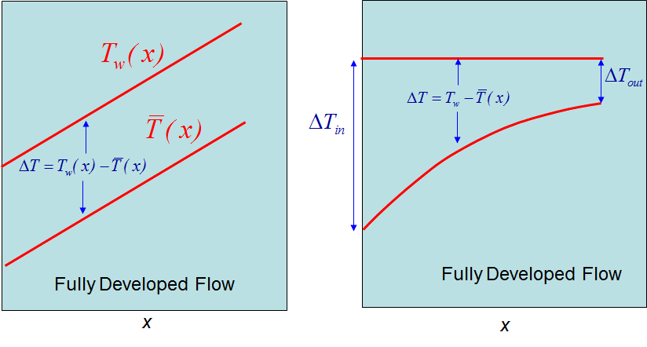

1. (a) Define ***log mean temperature difference*** for a fluid flowing inside a tube that is heated by a constant tube wall temperature. Assume the temperature of the fluid entering the tube as *Toin*and leaving the tube as *Toout*, whereas *Ts* is the temperature of the tube wall.



(b) Why the log mean temperature difference is more accurate than an arithmetic mean temperature difference the total heat transfer rate to a fluid flowing through a tube with a constant surface temperature. You don’t need to write an equation, a logical explanation would be enough.

Because the temperature does not vary linearly with x, see the plot above (right graph)

**[40 marks]**